Build an EMA-based Signal Strategy - Backtest
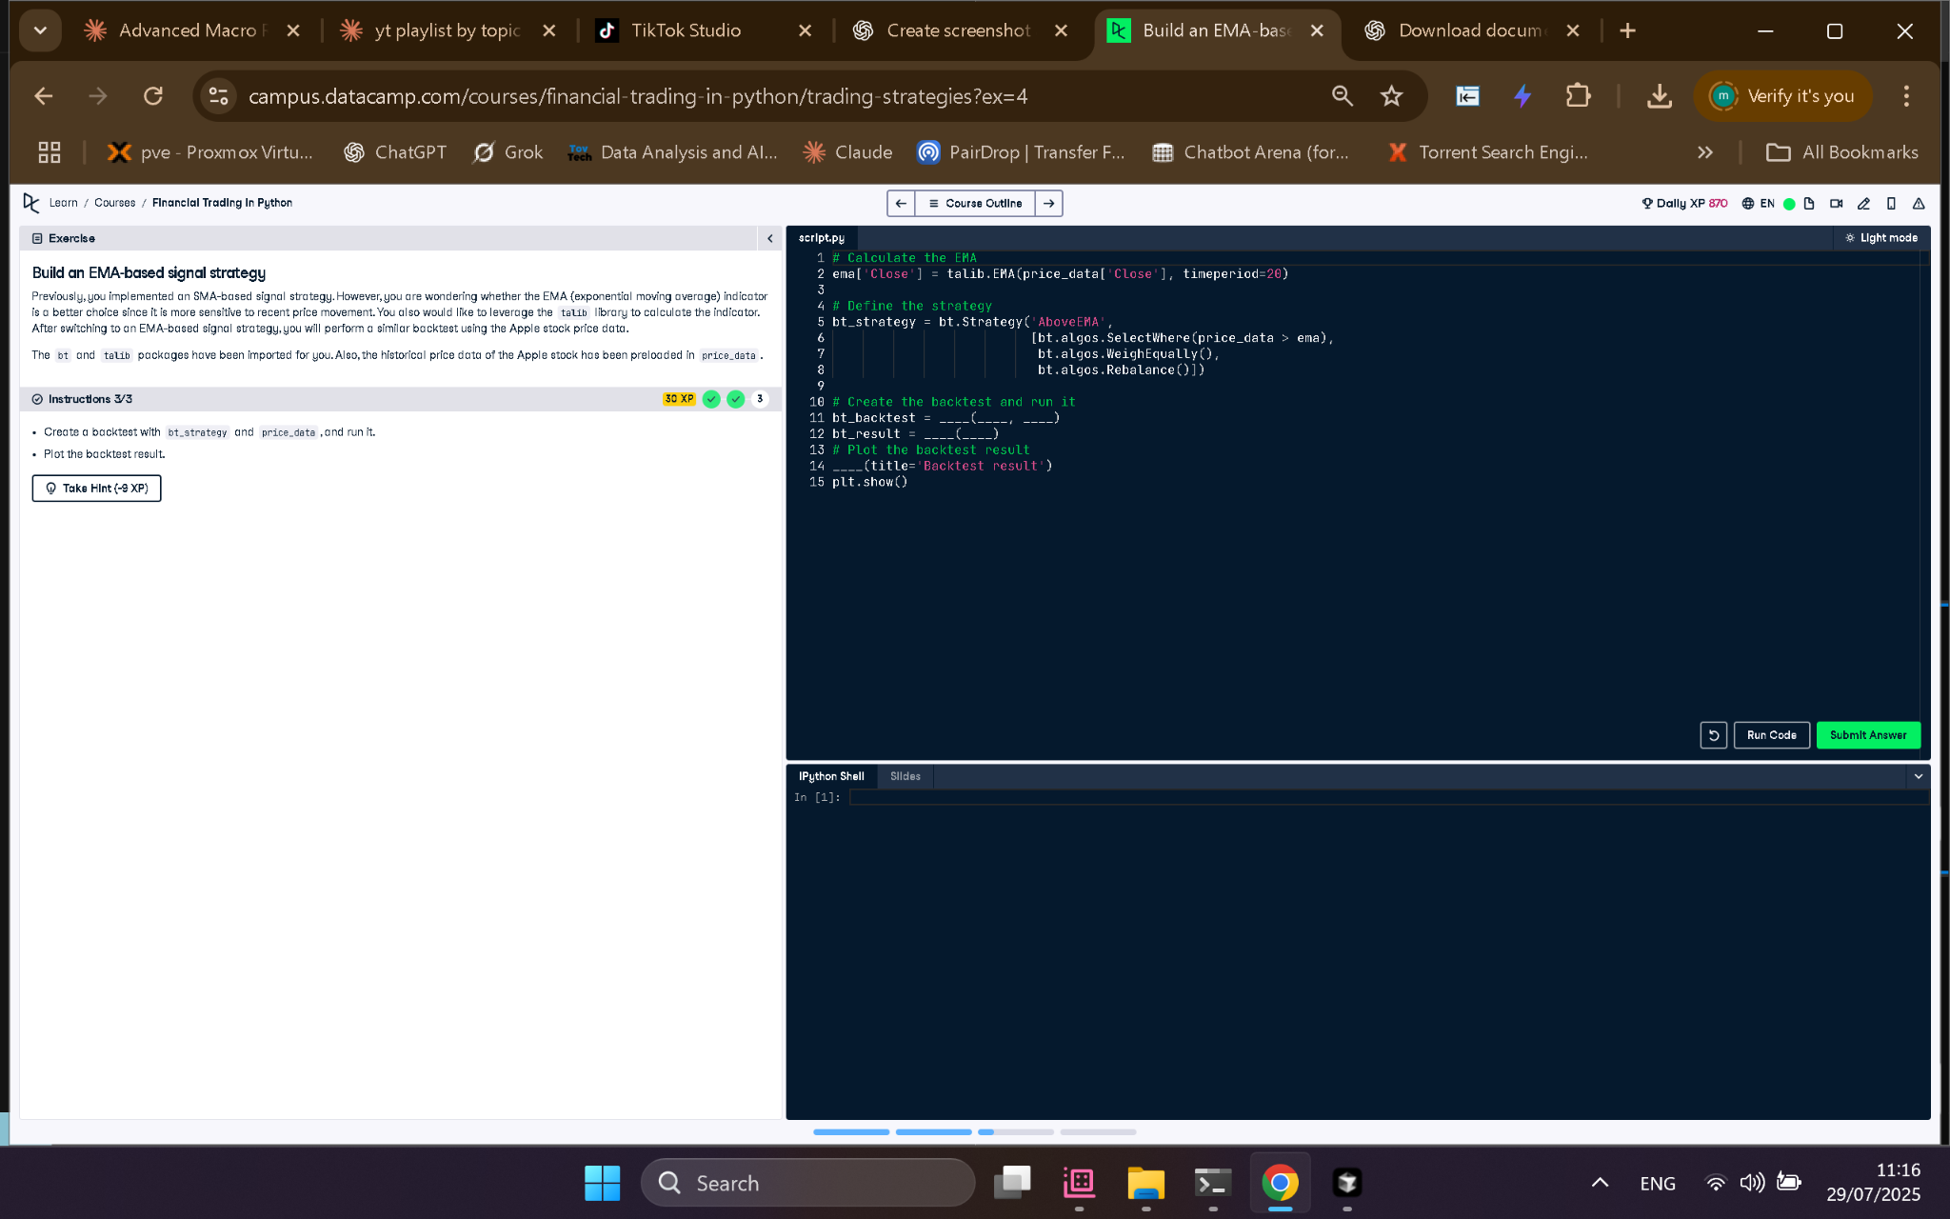

Python Code
# Calculate the EMA
ema['Close'] = talib.EMA(price_data['Close'], timeperiod=20)
# Define the strategy
bt_strategy = bt.Strategy('AboveEMA',
[bt.algos.SelectWhere(price_data > ema),
bt.algos.WeighEqually(),
bt.algos.Rebalance()])
# Create the backtest and run it
bt_backtest = bt.Backtest(bt_strategy, price_data)
bt_result = bt.run(bt_backtest)
# Plot the backtest result
bt_result.plot(title='Backtest result')
plt.show()

Explanation (in simple words)
This EMA-based strategy tests if stock prices are above their 20-day Exponential Moving Average. If so, the stock is selected, equally weighted, and rebalanced. The backtest then runs this logic on historical price data to show how well the strategy would have worked.

